Study Guide Genetics 101 Name:
mr. e Calvin Klein was not the first to express himself with Genes

Format: Test is split into 2 parts: part 1 ~ 14 multiple choice/T or F; 1 matching section (30 minutes)
part 2 ~ 3 Punnett Square Analysis problems (1 riddle; 2 breeding calculations of filial genotypic/color probabilities; 1- 1 ½ hrs.)

Vocabulary

Locus/loci heterozygous spotted/pied/patched
genotype self-colored (gerbil) recessive carrier
phenotype non-self-colored (gerbil) biome
homozygous recessive colorpoint sterile (reproductively)
homozygous dominant lethal spotting gene gestation period

Concepts:

Part 1

- Matching section on some vocab as well as your understanding of gerbil alleles/loci (eg. what codes for what?)

- Who is the "Father of Modern Genetics?" (offer more than a name)
If given a genotype, be able to calculate genotypic ratios at varying loci. (Eg. say I breed a homozygous pink-eyed gerbil with a heterozygous dark-eyed gerbil--what is the genotypic ratio of the kids?)

- Explain why the spotting gene is also known as the "lethal gene."

- Which aspect of alleles (dominance or recessive-ness) gives rise to greater variety?

- Use logic to decipher whether a certain couple can give rise to offspring with specific characteristics.

- Phenotypic sleuthing: If I give you a genotype, figure out its phenotype (color from gerbil color reference sheet--which you will be permitted to use for both parts of the test)

- Differentiate between self & non-self colored gerbils as well as spotted, pied, or patched gerbils from pictures.

- In which biome do Gerbils live in the wild?

Part 2

STEPS to determine the genotypes from parent organisms

1. write down your "cross" (mating)
2. draw a Punnett square for each allele pair cross
3. "split" the letters of the genotype for each parent & put them "outside" the P-square
4. determine the possible genotypes of the offspring by filling the squares
5. summarize results (genotypes [allele pairs & percentages] & phenotypes of offspring )

Eg.

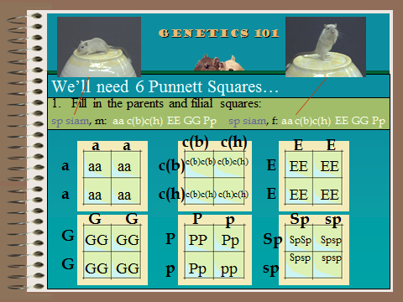

Step 1: cross

Step 2: Draw Punnett squares
Step 3: Write in parental alleles
Step 4: fill in

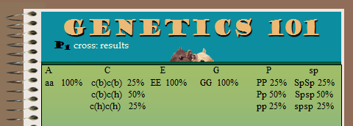

Step 5a: Summarize results according to each allele (percentage of each pair)

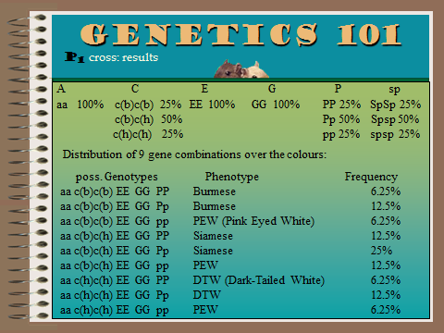
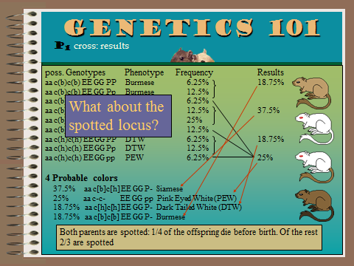
Step 5b: List all possible genotypes, match phenotype, and calculate percentage (frequency) for each.
Step 5c: Re-summarize results: Combine same phenotypes, adjust genotypes and add together final percentages (frequency) for each.
NOTE: Be sure to list probable colors in order of frequency: Highest to lowest.

