Basic Trout Dissection name:

Biology ~ fishes

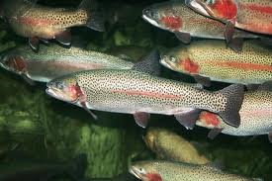Mr. e

GENERAL HINTS AND INSTRUCTIONS FOR DISSECTIONS

**Preparation:** Wash your animals in cold running water to remove slime and/or reduce fumes from the preservatives. KEEP ANIMALS MOIST WITH WATER DURING DISSECTIONS — dried out organs and tissues are impossible to dissect and maneuver. You should wear gloves to protect your hands.

Tools:

• **Scalpel**: This is the first tool that most people grab. It is the most dangerous one -both to the user and to the animal. The danger is, if you have a sharp scalpel, you can easily cut through important structures before you realize what you‘ve done. Thus, you should only use it when the scissors don‘t work. You should also be sure the blade is sharp.

• Scissors: These are the best tools for cutting through skin, etc. You can feel the different tissues better and are less likely to cut something important than you are with the scalpel. Be sure these are sharp; trade in dull ones immediately.

• Pick: Your "best friend" once inside the animal. This can easily be used to pull apart and cut the connective tissue that holds organs to each other, but it is unlikely to break anything important unless you push really hard. You should use this most of the time.

All dissection instructions must be left in lab. The lab must be left really clean—rinse your pans, pins, and instruments, dry them carefully, and return them to designated places; clean up benches and sinks.

Objective:

To give the students a chance to get a first hand look at the inside of a trout and how their bodies work.

Background:

They are distributed naturally throughout North America, northern Asia and Europe. As a group, trout are somewhat bony, but the flesh is generally considered to be tasty. The flavor of the flesh is heavily influenced by the diet of the fish. For example, trout that have been feeding on crustaceans tend to be more flavorful than those feeding primarily on insect life. Additionally, they provide a good fight when caught with a hook and line, and are sought after recreationally. Because of their popularity, trout are often raised on fish farms and planted into heavily fished waters, in an effort to mask the effects of overfishing. While they can be caught with a normal rod and reel, fly fishing is a distinctive method developed primarily for trout, and now extended to other species. Farmed trout and char are also sold commercially as food fish.Because trout are indicator species, scientists measure their populations and health to determine the health of a stream.

Materials:

A whole fresh or frozen (thawed) trout, Dissecting tools (scissors, tweezers or forceps, probe, magnifying glass), Newspapers and paper towels, Trout Anatomy diagram/ reference sheet to explain the function of each organ or characteristic.

Procedure:

1. Choose a location where students can view the dissection. Cover the surface with newspaper or a dissecting tray; label each **bold-faced** organ on the anatomy page (p 5) (external: **bold**; interna:l ***bold & italics***); if the organ is not represented, draw it in and label.

2. Study the external anatomy. Feel the fish’s skin and discuss what purpose the slime serves. Have students use the magnifying glass to examine the scales and note how they are arranged. Have students describe the color patterns and discuss function of coloration (camouflage). Observe the **lateral line**. Discuss what it is used for and the way it works. Describe the fish’s overall shape and how this adaptation is beneficial to the fish. Look at the placement of the fins and ask students to imagine the fish swimming in the water. How does it move? How are the fins used. Note the range of movement of each fin. Label **each fin**.

3. Allow students to feel the **bony rays** that support the fins. Have a volunteer count the number of rays on the anal fin. This is one of the most distinguishing characteristics of salmonids.

4. Notice the relatively large size of the **eye**s along with the large pupil tells us how important vision is for this animal. Have students note that there is no eyelid. Have them observe the tough, clear membrane that covers the eye. Rotate the eye in the socket with a finger.

5. Locate the **nostrils**. Describe the large olfactory lobes that are located in the brain. Ask students to speculate why a salmonoids smell receptors are so highly developed.

6. Open the **mouth**, note the color of the gums, feel the **teeth** along the gum margins and on the roof of the mouth. What function these teeth perform? Note how wide the mouth opens and comment on why this is. The mouth is also used for breathing. In low oxygen conditions, fish actively pump water over gills by opening and closing the mouth. Demonstrate this action with the fish’s mouth. (This structure is called the __________ ______). Label the **operculum**.

7. Point out the **gill arches** by having students look down the fish’s mouth. Use a probe to separate the arches and explore how they are arranged.

8. Place the fish on its side and look at the operculum—the bony plates which protect the gills. Lift the operculum to see the ***gills***. Cut the operculum away from its base, exposing the gills.

9. Remove the gills by cutting the upper and lower attachments of the arch. Look at the gill rakers, the bony projections along the inside curve of the arches. Observe the large surface area provided by the ***gill filaments***, and the thin tissue which allows blood vessels to come into contact with the oxygen in the water. Compare and contrast gills and lungs.



10. Carefully cut the fish open using the scissors or scalpel. Observe how all the internal organs fit together. Look for the thin transparent membrane that encloses the organs. Cut away the flap of skin and look for fat deposits, which are found around the stomach.

11. Look for the ***swim bladder***. It is made of very thin tissue and is located in the upper body cavity, below the ***kidneys***. It will be less developed in small fish and will not be inflated. It may be hard to find. If you can’t find it, beckon your teacher to point to its location and discuss its function.

12. The male reproductive organs will be a flaccid white or orange tissue near the intestines. Eggs may or may not be noticeable in females and vary in size depending the fishes maturity. Find whichever reproductive structures are present, draw them and label them ***gonads***.

13. Put the fish on its back to find the ***kidney***, located under the backbone. They are thin, dark in color and run the length of the body cavity. Ask a volunteer to discuss kidney functions.

14. Investigate the digestive tract by starting in the mouth and following the route that food would take. Put the probe through the mouth and ***esophagus*** to show the route. Follow the course of the stomach using a finger or probe. The first area of the stomach is called the ***cardiac stomach*** (where digestion begins.) Notice the different kinds of tissue that make up the stomach.

15. The ***pyloric stomach*** (portion from which the pyloric ceca project) is made of different tissue and begins at bend below the cardiac stomach. Stomach area is increased by the pyloric ceca, how does this improve the function of the stomach.

16. The ***intestine***s extract nutrients from food. A network of blood vessels are used for nutrient exchange. Follow the intestines to the ***anal opening***, where waste products are eliminated.

17. Lift the stomach to show/discuss the ***spleen*** (reddish organ near end of the cardiac stomach.)

18. The ***liver*** is in front of the stomach. Discuss it's role in the digestion of fats. Point out the ***gall bladder***, a mass of darker tissue on the liver.

19. Locate the ***heart***, found near the fish’s mouth. Make out the different chambers. The gills, heart, and liver close together for a reason. Blood pressure is best near the heart (pump). Blood is filtered by the liver, and absorbs oxygen from the gills; both are vital functions.

20. Cut through the fish to expose the backbone, muscles and muscle mass (this is the part we eat.)

21. Carefully cut away the skin by lifting it while running the scalpel along the skin-muscle interface. The skin may be thin enough to place under a microscope or magnifying glass to observe the pattern of the scales and the growth rings. Remove scales to look at the rings.

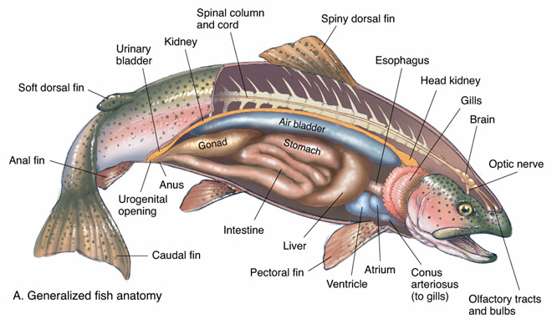 22. Praise your Creator for making fish so cool.

Trout: external anatomy

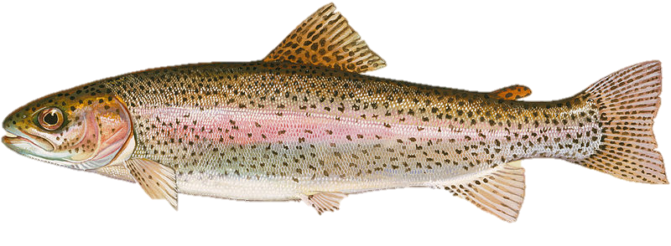

Trout: internal anatomy



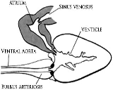

deep to gills