Paper Airplane Competition Team Name:
Data Sheet Team Members:

- Aesthetics: rank them 1st through 3rd by writing its number next to its rank.

Your Ranking: Plane# Class Ranking: Plane # Points
1st:_________ 1st:___________ 3 pts.
2nd:_________ 2nd:___________ 2 pts.
3^{rd:}__________ 3rd:____________ 1 pt.

- Time in Flight

Trial # | Time (sec) | Best trial
1
2
3

- Distance

Trial # | Class Rank
1
2
3
 | Rank Total:

(lowest wins)

- Accuracy

Trial # | Class Rank
1
2
3
 | Rank Total:

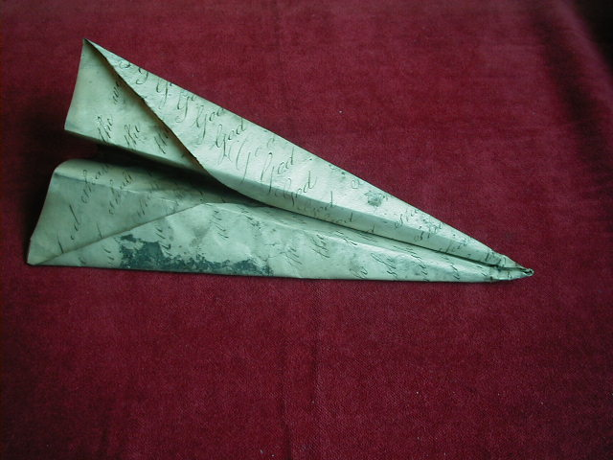
(lowest wins)

